What is cloud computing ?

>> The on-demand delivery of IT-resources over the internet is called cloud computing

Client – server Model :

* Modern computing Is based on the client-server Model
* **Client** can be a web browser or desktopapplication a person interacts with to make requests to computer servers.
* **Server** can be a services such as AWS EC2, a type of virtual server.

**EX:** suppose that a **client** makes a new request for a news article, the score in an online game, or a funny video. The **server** evaluates the details of this request and fulfils it by returning the information to the client.

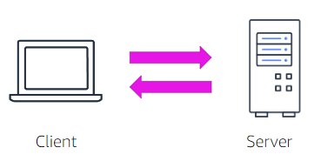

**Six benefits of cloud computing :**

* **Trade upfront expense for variable expense**
* **Stop spending money to run and maintain datacenters**
* **Stop guessing capacity**
* **Benefit from massive economies of scale**
* **Increase speed and agility**
* **Go global in minutes**

**Deploying to the cloud**

* **Cloud service and deployment methods provide different levels of control, flexibility and management**
* **Deployment models include**
  + **Infrastructure as a service ( IAAS )**
  + **Platform as a service ( PAAS )**
  + **Software as a service ( SAAS )**
* **Infrastructure as a service :**

**>> IAAS** contains the basic building blocks for cloud IT. It typically provides access to networking features, computers ( virtual or dedicated hardware ) and data storage space. Infrastructure as a service provides the highest level of flexibility and management control over your IT resources.

**EX:** Many AWS services are considered Iaas, including Amazon EC2, Amazon simple storage (S3), Amazon RDS and Amazon Route 53.

* **Platform as a service ( PAAS ) :**

>> PAAS removes the need for organizations to manage the underlying infrastructure ( usually hardware and operating systems ) they can focus on the deployment and management of applications.

>> These tools will give the developers ability to be more efficient because they don’t need to worry about resource procurement, capacity planning, software maintainance and patching.

EX : AWS Elastic Beanstalk ( This service is used for quickly deploying and scaling web applications )

* **Software as a service ( SAAS ) :**

>> SAAS is a completed software product that the service provider runs and manages with a saas offering, you do not have to think about how the service maintained or how the underlying infrastructure is managed.

>> You only must think about how you will use that particular piece of software .

EX: video meeting sites, email sites, file sharing sites and messaging apps

* **Deployment strategies include :**
  + **Cloud**
  + **Hybrid**
  + **On-Premise**
* Each type of deployment model and strategy has a shared responsibility between you and the cloud service provider

**Your choice of deployment model depends upon the desired infrastructure, storage needs, and access requirements**

* **Cloud :**
  + In cloud based deployment, you can migrate existing applications to the cloud, or you can design and build new applications in the cloud.
  + You can build those applications on low-level infrastructure that requires your IT staff to manage them. Alternatively, you can build them by using higher level services that reduce the management, architecting, and scaling requirements of the core infrastructure.

**EX:** a company might create an application that consists of Virtual servers, databases, and networking components that are fully based in the cloud.

* **Hybrid :**
  + In a hybrid deployment, cloud-based resources are connected to on-premises infrastructure. You can integrate cloud based resources with legacy IT applications.
  + You might want to use this approach in a number of situations . For ex : you have legacy applications that are better maintained on premises or government regulations require your business to keep certain records on premises.

EX : suppose that a company wants to use cloud services that can automate batch data processing and analytics. However, the company has several legacy applications that are more suitable on premises and will not be migrated to cloud. With a hybrid deployment, the company would be able to keep the legacy applications on premises while benefiting from the data and analytics services that run in the cloud.

* **On-Premises :**
  + On-Premises deployment is also known as a private cloud deployment. In this model, resources are deployed on premises by using virtualization and resource management tools. Increase resource utilization by using application management and virtualization technologies.

For ex : you might have applications that run on technology that is fully kept in your on-premises data center. Though this model is much like legacy IT infrastructure, its incorporation of application management and virtualization technologies helps to increase resource utilization.

**AWS Global Infrastructure :**

**Region :**

>> AWS has a the concept of a region, which is a physical location around the world where data centers are clustered together.

>> A group of logical data centers is called an Availability Zone

>> Each AWS Region consists of multiple, isolated and physically separated Availability zones within a geographic area.

**Availability Zone :**

**>>** An Availability zone is a zoned area within a Region that can harbor one or more data centers ( typically three ) . Availability Zones house all the hardware devices that AWS offers.

>> With their own power infrastructure, the Availability Zones are physically separated by a meaningful distance ( up to 100 KM or 60 miles ) from any other Availability zone in the Region

>> Availability Zones are interconnected with high-bandwidth, low-latency networking to provide low-latency networking between zones that is sufficient to accomplish synchronous replication (same time replication )

**Edge location :**

**>>** Edge locations are connected to the AWS Regions through the AWS network across the globe. They link with tens of thousands of networks for improved origin fetches and dynamic content acceleration.

>> Edge locations cache copies of your content for faster delivery to users at any location. They support AWS services like Amazon Route 53 and Amazon cloudFront.

>> AWS has over 200 edge locations that are placed in 90 cities, across 47 countries.

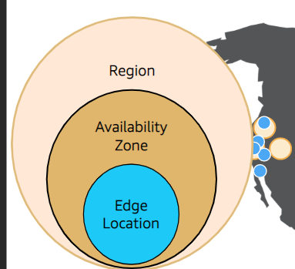

* Whenever you are building something on cloud you need to design by planning for failure.

**In storage level 🡪**  when a file is stored in Amazon S3, the file is redundantly copied into every Availability Zone in that Region . If one AZ goes down, you still have two copies of that file available for you to use.

**In compute level ->** It is a best practice to spread out your computing resources across multiple Availability Zones to guarantee high availability so, if one Availability Zone goes down, your architecture is still up and running.

**In database level ->** You can configure your database for Multi-AZ deployment. If your Availabilty zone with your primary database fails, one of the standby databases in a healthy Availability Zone automatically becomes your new primary database. Therefore your architecture is still functioning.

**Benefits of AWS Global Infrastructure :**

* **Performance**
* **Availability**
* **Security**
* **Reliability**
* **Scalability**
* **Low Cost**

**Shared responsibility Model :**

* It is a security model that Is used to protect cloud environment that uses AWS services.
  + AWS is responsible for the security of the cloud and Customer is responsible for the security in the cloud.

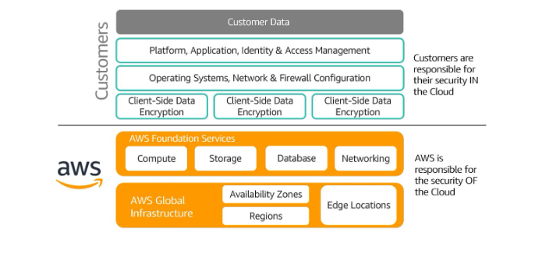

**AWS Well-Architected Framework :**

**5 pillars of AWS well-Architected framework are :**

1. **Operational Excellence**
2. **Security**
3. **Reliability**
4. **Performance & Effeciency**
5. **Cost optimization**

**Operational Excellence :**

* It is the ability to run & Monitor systems to deliver business value and to continually improve supporting processes and procedures
* Design principles for operational excellence in the cloud include performing operations as code, annotating documentation, anticipating failure, and frequently making small, reversible changes.

**Security :**

* Security pillar is the ability to protect information, systems and assets while delivering business value through risk assessments and mitigation strategies.
* When considering the security of your architecture, apply the best practices:
  + Automate security best practices when possible
  + Apply security at all layers
  + Protect data in transit and at rest

**Reliability :**

* It is the ability of a system to :
  + Recover from infrastructure or service disruptions
  + Dynamically acquire computing resources to meet demand
  + Mitigate disruptions such as transient network issues or misconfigurations
  + Testing recovery procedures
  + Scaling horizontally to increase aggregate system availability
  + Automatically recovering from failure

**Performance Efficiency :**

* + It is the ability to use computing resources efficiently to meet system requirements and to maintain that efficiency as demand changes and technology evolve.
  + Evaluating the performance efficiency of your architecture includes experimenting more often, using serverless architectures, and designing systems to be able to go global in minutes.

**Cost Optimization :**

* + It is the ability to run systems to deliver business value at the lowest price point
  + Cost optimization includes adopting a consumption model, analyzing and attributing expenditure, and using managed services to reduce the cost of ownership.

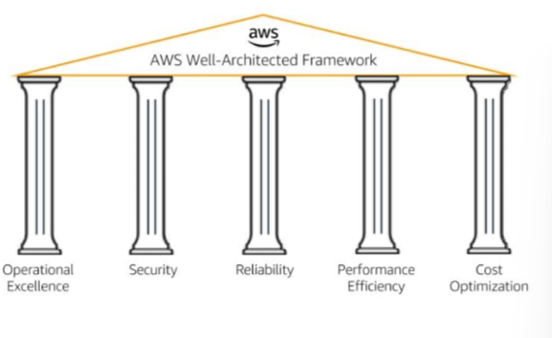

* **AWS well architected tool** is a free tool that Review your answers against the five pillars established by the well architected framework . It works by taking inputs from the user and providing the plan of action to implement well architecture framework on his/her workloads.

**Cost and Billing :**

**Aws pricing calculator** is a tool used to calculate the cost incurred to use a particular service.

* Pay as you go, save when you reserve and pay less by using more are some of the AWS pricing models.
* To monitor, analyze and view in dashboard format of bills of your AWS account in **AWS Billing Dashboard.**

**AWS has three main types of services , They are**

1. **Managed services**
2. **Fully Managed services**
3. **Serverless Services**

**Managed Services :**

**>>** A managed service is a way to describe the services that require you to mange infrastructure management tasks like patching, backup and repair.

>> These services grant you virtual access to the underlying operating system and servers. With managed services, you are responsible for scaling and building for high availability.

**Fully Managed services :**

**>>** A fully managed service is a way to describe the services that automate infrastructure management tasks that AWS handles, like patching, backup and repair.

>> These services do not grant you any virtual access to the underlying operating system or servers. With a fully manged service, you are still responsible for scaling and building for high availability.

**Serverless Services :**

**>>** serverless is a way to describe the services, practices and strategies that you can use to build more agile applications

>> In this way, you can innovate and respond to change faster.

>> With serverless services, AWS handles infrastructure management tasks like capacity provisioning and patching so that you can focus on building applications that serve your customer.

>> Serverless services come with automatic scaling, built-in-high availability, and a pay-for-value billing model.

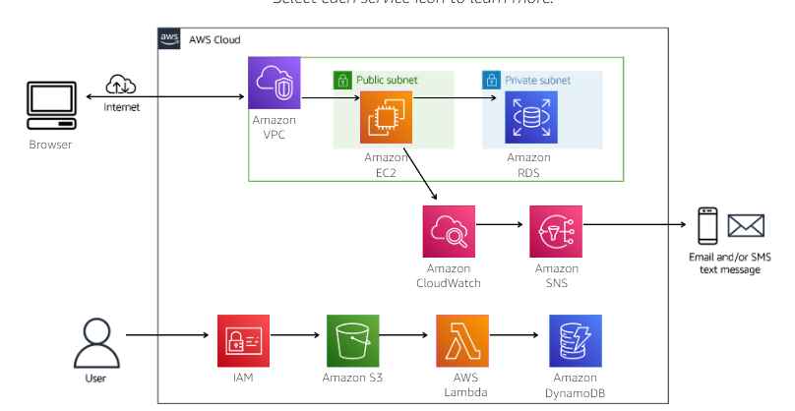

**Amazon Virtual Private Cloud ( VPC ) :**

**What does Amazon VPC do ?**

**>>** Amazon VPC is a service that you use to launch AWS resources in a logically isolated virtual network that you define

>> As a foundational AWS service, Amazon VPC makes it easy to customize your VPC’s network configuration. You can create public facing subnet for your web servers that have access to the internet.

>> you can also use the amazon VPC to place your backend systems such as databases or application servers, in a private-facing subnet with no internet access.

>> with Amazon VPC , you can use multiple layers of security to help control access to Amazon EC2 instances in each subnet.

>> These layers include security groups and network access control lists ( network ACLs )

**What problems does Amazon VPC solve ?**

**>>** It provides features that you can use to increase and monitor the security for your virtual private cloud ( VPC ) on demand.

>> Therefore, you can create a data center as you need it and terminate it when you no longer need it.

**What are the benefits of Amazon VPC ?**

**>>** Amazon VPC provides advanced security feature that you can use to perform inbound and outbound filtering at the instance and subnet levels.

>> with simple setup of Amazon VPC, you spend less time setting up, managing and validating. Therefore you can concentrate on building applications that run in your VPCs.

>> Amazon VPC helps you control your virtual networking environment . By using Amazon VPC, you can choose your own IP address range, create your own subnets, and configure route tables to any available gateways.

**How can I architect a cloud solution using Amazon VPC ?**

**>>** The diagram below shows how you can use a VPC to build a solution that has both pubic subnet and private subnet.

>> The public subnet has an EC2 instance that hosts a web application that has access to the internet.

>> The private subnet has an RDS instance that is protected from direct access to the internet.

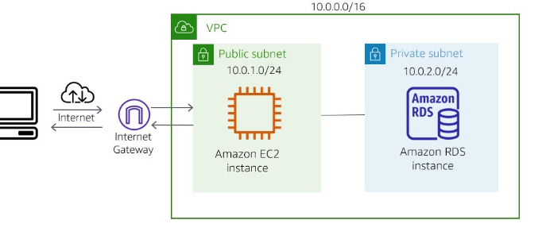

**How can I use Amazon VPC ?**

**>>** we can use VPC build the following solutions

Host a simple website

* + - You can use Amazon VPC to host a basic web application such as blog or simple website. You’ll gain the additional layers of privacy and security that the VPC configuration options provide

Host multi-tier web applications

* + - We can use VPC to host multi-tier web applications and strictly enforce access and security restrictions between your web servers, application servers and databases.
    - To achieve this result, you launch web servers in publicly accessible subnets while running your application servers and databases in private subnets. This technique will ensure that application servers and databases cannot be directly accessed from internet.

Backup and recover

* + - By using Amazon VPC for disaster recovery, you receive all the benefits of a disaster recovery site at a fraction of the cost.
    - you can periodically backup critical data from your data center to a small number of Amazon EC2 instances.
    - Alternatively, you can import your virtual machine images to Amazon EC2 .
    - To ensure business continuity, you can use amazon VPC to quickly launch replacement compute capacity in AWS.
    - When the disaster is over, you can send your mission-critical data back to your data center

Extend your corporate network

* + - You can use a VPC to move corporate applications to the cloud or launch additional web servers. You can also use a VPC to add more compute capacity to your network.
    - Because your vpc can be hosted behind your corporate firewall, you can seamlessly move your IT resources into the cloud.
    - You don’t need to change how your users access these applications.

**What else should I Keep in mind when using Amazon VPC ?**

* + - when you create a new Amazon VPC, you have the option to create one by using a template or create one from scratch
    - When you create one from scratch, automatically it will create a route table, a network ACL, and a security group. Then, you configure them according to your needs
    - You must delete a VPC, be sure to first terminate any EC2 or RDS instances that you have provisioned in the VPC.

**How much does Amazon VPC cost ?**

* + - **An** amazon VPC doesn’t cost you anything at a basic level. In fact, when you set up your AWS account, you are given a default VPC.
    - A VPC consists of many components that do not cost you anything, such as subnets, route tables, network ACL’s , security groups, and an internet gateway.
    - We can add features to your amazon VPC, such as NAT gateway and elastic Ips that do have associated charges.
    - Also, any service that you place in your amazon VPC, such as Amazon EC2, will carry with it associated cost for that service

**Amazon EC2 :**

**What does Amazon EC2 do ?**

**>>** Amazon EC2 is a web service that provides secure, resizable compute capacity in the cloud . It is designed to make web-scale cloud computing easier for developers.

>> You can use the simple web interface of Amazon EC2 to obtain and configure capacity with minimal friction.

>> It provides you with complete control of your computing resources, and you can run it on the proven computing environment of amazon.

**What problems does Amazon EC2 solve ?**

**>>** amazon EC2 solves the problem of predicting upfront needs. Therefore, you don’t need to know how much compute capacity or how much hard drive volume you will need when you set up your architecture. You can scale up and down as you need to.

**What are the benefits of Amazon EC2 ?**

**>>** We can provision an EC2 instance in as little as 5 minutes. It gives you the options to select the right CPU, storage, and operating system for your specific needs.

>> with Amazon EC2, you can change the volume size and the instance type without terminating the instance.

>> You can use Amazon EC2 to scale up and down to meet seasonal needs. You don’t need to have extra servers on hand that are used for only a few months out of the year.

**How can I architect a cloud solution using Amazon EC2 ?**

**>> With Amazon EC2, you can architect a solution to build a multi-tier application**

**>> To construct this solution, you create an instance in public subnet that hosts a website with security group that allows internet traffic in and out. Then, you can create another instance that hosts a database in a private subnet with a hardened security group.**

**>> This security group restricts internet traffic, but allows the website instance to access the database instance.**

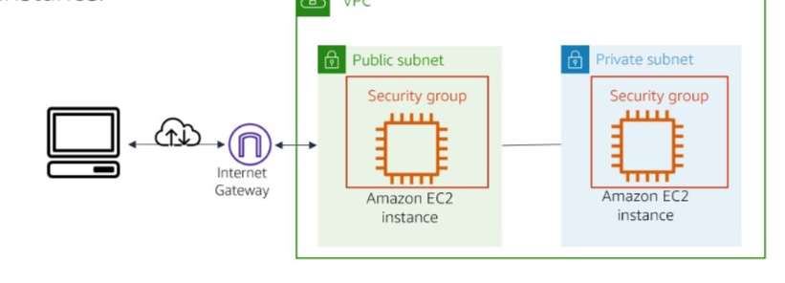

**How can I use amazon EC2 ?**

**>> Host a multi-tier application**

* **Amazon EC2 can be used to create multi-tier web applications. With security groups, you control the kind of port traffic that can reach your instance.**
* **You can configure your security group and attach it to your instance. And you control the traffic that can enter each layer of architecture.**

**>> Backup and disaster recovery**

* **With amazon Ec2, you can create a backup instance if your main instance fail. In the event of failure, you can scale up your backup instance until you get your main instances back online.**
* **Then, scale your backup instances back down when recovery of your main instances is complete. Amazon EC2 instances can act as a backup for cloud or on-premises instances.**

**>> On-demand computing**

* **Amazon Ec2 lets you provision instances to perform computing jobs and terminate them when you are done.**
* **This arrangement can save you a lot of money, if you only need the computing resource for a few hours, days, or weeks.**

**>> Host databases**

* **AWS offers fully managed and serverless database services that you can provision for all your database needs.**
* **However, with both fully managed services and serverless services, you don’t have access to the operating system of the database.**
* **But you can host your own database on an EC2 instace, if your company requires you to have that access.**

**What else should I keep in mind when using Amazon EC2 ?**

* **If you stop an instance, the Amazon Elastic Block Store (Amazon EBS ) volume that is attached will retain your data.**
* **You will still be charged for use of the volume. However, if you terminate the instance, then all your data on the volume will be permanently deleted.**
* **The volume will return to AWS for available use to other AWS customers.**

**How much does Amazon Ec2 cost ?**

* **Amazon EC2 has three main pricing models.** 
  + **On-demand instances**
    - **With on-demand instances, you pay for instances only for the amount of time you use them . No longer commitment or upfront payments are required.**
    - **You can increase or decrease your compute capcity depending on the demands of your application and pay only for time you use them.**
      * **Use case :** Short-term computing workloads that cannot be interrupted and users that need low-cost computing without any upfront or long-term commitment.
  + **Spot instances**
    - You can use Amazon EC2 spot instances to take advantage of unused Amazon EC2 capacity in the AWS cloud for a discount.
    - You can save upto 90 percent compared to on-demand prices
    - To get a spot instance, you submit a request with the instance specifications and the maximum price that you are willing to pay per hour.
    - When a spot instance is available at your submitted price, you will have access to the instance.
      * **Use case :** workloads that can be paused and restarted when computing prices meet your budget for spot instances.
  + **Reserved Instances**
    - Reserved instances provide you with a significant discount (upto 75 percent ) compared to 0n-demand instance pricing.
    - With Reserved Instances, you commit to paying for the instance for 1 or 3 years, depending on the conditions you agree to when purchasing them.
      * **Use case :** computing needs with a steady amount usage of up to 1 year or more .

**Amazon RDS :  
 what does Amazon RDS do ?**

* Amazon RDS is a distributed relational database manged service. It Is cloud based and designed to simplify the setup, operation, and scaling of relational databases.
* Administrative processes like patching, backup databases and enabling point in time recovery are managed automatically.

**What problems does Amazon RDS solve ?**

* Amazon RDS solves the problem of purchasing a database with capacity that is either too large or too small for your use over time.
* With Amazon RDS, you can scale up and down based on your database capacity needs. As a result, you are never paying for more database capacity than you need.

**What are the benefits of Amazon RDS ?**

* Amazon RDS is easy to administer with no need for infrastructure provisioning, and no need for installing and maintaining database software. With few mouse clicks or an API call, you can scale your database’s compute and storage resources as needed.
* Amazon RDS is fast and supports the most demanding database applications. You can run your database instance in Amazon Virtual Private Cloud ( VPC ) which enables you to isolate your database instances. Alternatively you can connect your database instances to your existing IT infrastructure through an industry-standard encrypted IPsec virtual private network ( VPN )

**How can I architect a cloud solution using Amazon RDS ?**

* You can architect a solution to build for fault tolerance by configuring Amazon RDS for Multi-AZ deployment. To accomplish this task, you place your master RDS instance in one Availability Zone and a standby replica of the master in another Availability Zone.
* If the primary fails, then the standby automatically becomes the new master and your system remains active.

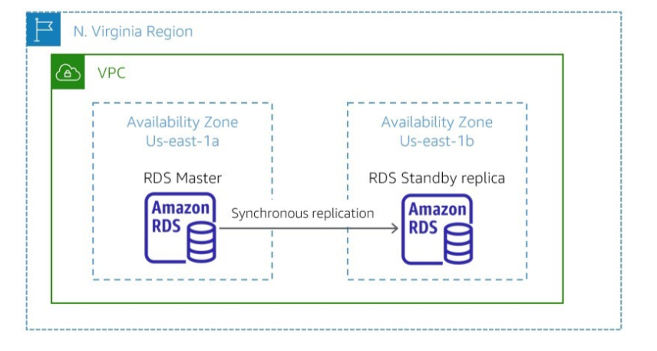

**How can I use Amazon RDS ?**

* **Web and mobile applications**
  + Web and mobile applications that are build to operate at very large scale need a database with high throughput, massive storage capability, and high availability
  + Amazon RDS fulfils the needs of such highly demanding applications with room for future growth.
  + Because Amazon RDS does not have any licensing constraints, it perfectly fits the variable usage patterns of these applications
* **Ecommerce Applications**
  + RDS offers small and large ecommerce businesses a flexible, secured, highly scalable and low-cost database solution for online sales and retaining.
  + Amazon RDS provides a managed database offering to help e-commerce companies meet payment card industry ( PCI ) compliance and focus on building high quality customer experience.
  + They don’t need to worry about managing the underlying database.
* **Mobile and online games**
  + Mobile and online games need a database platform with high throughput and highly availability.
  + Amazon RDS manages the database infrastructure. So, game developers don’t have to worry about provisioning, scaling or monitoring database servers.
  + Amazon RDS provides familirar database engines that can rapidly grow capacity to meet user demand.

**What else should I keep in mind when using Amazon RDS ?**

* + **Amazon** RDS is fully managed “fully managed” means that AWS automates the mainatainance and security of the database instance without you doing anything.
  + **However, you might need access to** manage the operating system and update security patches yourself. If so, then you can provision an EC2 instance and use I t to host your own database.
  + **Suppose that you decide to** host your own database on an EC2 instance. Then you are responsible for many of the automated tasks that Amazon RDS would automatically perform for you.

**How much does Amazon RDS cost ?**

* + **Amazon** RDS pricing follows the pay for only for what you use model. It has no minimum fee.
  + **You can pay** for Amazon RDS by using On-Demand or Reserved instance types that are optimized to fit different relational database use cases.

**Amazon cloud-watch :**

**What does Amazon Cloud watch do ?**

* Amazon Cloud watch is a monitoring and observation service built for Devops Engineers, developers, security engineers, and IT Managers
* Cloud watch provides you with data and actionable insights to monitor your applications, respond to system-wide performance changes, and optimize resource utilization. You get unified view of operational health.

**What problems does cloud watch solve ?**

* Amazon cloud watch solves the problem of responding to events and alarms, as they occur in your architecture.
* Amazon cloud watch collects monitoring and operational data in the form of logs, metrics and operational data in the form of logs, metrics and events
* It provides you with a unified view of AWS resources, applications and services that run on AWS and on premises servers.
* You can use cloud watch to detect anomalous behaviour in your environments, set alarms, and visualize logs and metrics side by side
* Use it to take automated actions, troubleshoot issues, and discover insights to keep your applications running smoothly.

**What are the benefits of Cloud watch ?**

* **You can** use cloud watch to collect metrics and logs from all your AWS resources, applications, and services that run on AWS and on-premises servers. You can monitor them from one platform
* **You can use** cloud watch to maintain visibility across your services, applications, and infrastructure, so you can visualize key metrics like CPU Utilization and memory.
* **You can use** cloud watch to set alarms and take automated actions. It frees up important resources so you can focus on adding business value.

**How can I architect a cloud solution using Cloud watch ?**

* You can architect a solution by using Amazon Cloud watch to monitor the CPU utilization and take action

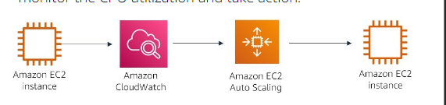

* **In the** diagram, CloudWatch receives data on the EC2 instance CPU utilization, when the CPU goes over a specified percent, cloud watch triggers Amazon EC2 Auto Scaling to provision an additional instance to help with the workload.
* Therefore, the first instance isn’t overloaded.

**How can I use Cloud Watch ?**

* **Infrastructure Monitoring and Troubleshooting**
  + You can use cloud Watch to monitor key metrics and logs, visualize your application and infrastructure stack, and create alarms.
  + It correlates metrics and logs to understand and resolve the root cause of performance issues in your AWS resources
* **Proactive Resource optimization**
  + Cloud watch alarms watch your metric values against thresholds that you specify or that cloud watch creates by using machine learning models to detect anomalous behavior. For ex : if an alarm is triggered, cloud Watch can take action automatically to enable Amazon ec2 auto scaling or stop an instance.
  + In this way, you can automate capacity and resource planning
* **Application Monitoring**
  + Cloud watch can monitory your applications that run on AWS (on Amazon EC2, containers, and serverless ) or on-premises.
  + Cloud Watch collects data at every layer of the performance stack, including metrics and logs on automatic dashboards.

**What else should I keep in mind when using Cloud Watch ?**

* + **Some** services provide basic cloud watch monitoring at no additional charge with the option to upgrade to detailed monitoring, which comes with a charge.
    - **EX :** EC2 instances, by default, are enabled with basic cloud watch monitoring. Thus , data is available automatically in 5 minute periods.
    - If you decide to upgrade to detailed cloud watch monitoring on your instances, data is available in 1-minute periods instead of 5 minute periods.

**How much does Cloud watch cost ?**

* + Amazon cloud watch does not require an upfront commitment or minimum fee; you pay for what you use and that too at the end of the month for your usage.
  + Amazon cloud watch charges you for alarms, custom events, metric collection and dashboards that you setup. However, you can get started with Cloud Watch for free.
  + Most AWS Services ( Amazon EC2, Amazon S3, Amazon Kines, and others ) Send metrics automatically for free to cloudwatch.
  + Many applications should be able to operate within free tier limits.

**Amazon SNS :**

**What does Amazon SNS do ?**

* **Amazon simple notification service (Amazon SNS ) is a web service that makes it easy to set up, operate and send notifications from the cloud.**
* It provides developers with a highly scalable, flexible and cost-effective capacity to publish messages from an application and immediately deliver them to subscribers.
* These subscribers can be notification recipients or other applications

**What problems does Amazon SNS solve ?**

* Amazon SNS solves the problem of appropriate subscribers not getting important information that they should be aware of, as events occur in their applications or infrastructure.

**What are the benefits of Amazon SNS ?**

* You can use Amazon SNS to send messages or notifications directly to users across 200 countries. Messages can be sent with SMS text messages, mobile push on apple, android, and other platforms, or email ( SMTP )
* Amazon SNS uses a number of strategies that work together to provide message durability
* If a subscribed endpoint isn’t available, Amazon SNS initiates a message delivery retry policy to resend the message.

**How can I architect a cloud solution using Amazon SNS ?**

* **You can use** Amazon SNS to create a solution to notify you or failures in the architecture.

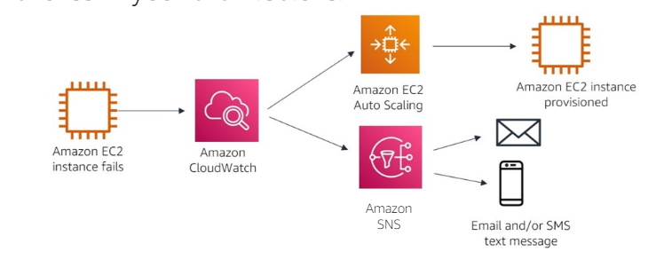

* In this diagram, Amazon EC2 instance fails and Amazon Cloud watch is notified. Cloud watch then triggers an action to create a new instance through AWS Autoscaling.
* At the same time, cloud watch triggers Amazon SNS to notify the appropriate subscribers, so that they can investigate the issue further.

**How can I use amazon SNS ?**

* We can use amazon SNS to create topics. A topic is an access point, which identifies a specific subject or event type .
* SNS topics are defined as standard topics or First-In-First-Out ( FIFO ) topics.

**Standard :**

* Standard topics can be used in many scenarios.
* If your application can process messages that arrive more than once and out of order.
* EX: Fanning out messages to media encoding, Fraud detection, tax calculation, search index, and critical alerting systems.

**FIFO :**

* FIFO topics are designed to enhance messaging between applications when the order of operations and event is critical , or where duplicates can’t be tolerated. EX : fanning out messages to bank transaction logging, stock monitoring, flight tracking, inventory management, and price update systems.

**What else should I keep in mind when using Amazon SNS ?**

* Amazon SNS cannot automate messages by itself, it must work with a service such as amazon Cloud watch or AWS Lambda that can monitor what is going on in your architecture.
* The service must also be able to trigger Amazon SNS to send a notification, based on your system’s configurations.

**How much does Amazon SNS cost ?**

* Amazon SNS has no upfront fees, no required commitments, and no long-term contracts. You pay only for what you use, based on the type of topic that is used.

**IAM :**

**What does IAM do ?**

* **IAM** is a centralized security Management system that is included in every AWS account to control identity access to AWS Services.
* By attaching IAM permission policies to identities, you can manage which services each identity can access and the kind of actions the identity can perform.

**Identities in IAM are users, groups and roles.**

**USER :**

* IAM user is an entity that you create in AWS. The IAM user represents the person or service who uses the IAM user to interact with AWS.

**GROUP :**

* IAM user group is a collection of IAM users. You can use user groups to specify permissions for a collection of users, which can make those permissions easier to manage for those users.

**ROLE :**

* An IAM role is an identity with permission policies that are attached to it. An IAM user or service can assume these policies to temporarily take on different permissions for a specific task.

**What problems does IAM solve ?**

* IAM solves the problem of users having more access that they should
* IAM is built by using the principle of least privilege.
* The principle states that an identity will not have access to any AWS service until you grant the identity access.
* By this method, no one should be able to provision or access resources that you have not explicitly granted them access to it.
* EX : if you create a new user, then that user cannot access the EC2 Dashboard by default, you must attach an IAM policy to that user to grant them access to the EC2 Dashboard.

**What are the benefits of IAM ?**

* IAM has a simple user interface that makes it easy to grant and control user access to AWS service
* IAM has many system-generated policies that you can use, and you can create additional custom policies that meet the needs of your specific requirements

**How can I architect a cloud solution using IAM ?**

* Using IAM roles, you can grant someone from a different AWS account access to your account to perform a specific task.

**In the diagram, a user in the dev account is assuming a role in the production account.**

**The role returns a temporary security credential.**

**It grants the user temporary access to the AWS service based on the policy that is attached to the role.**

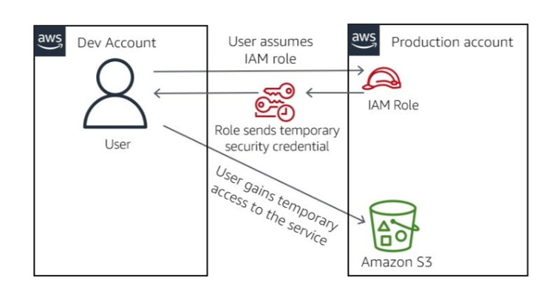

**How can I use amazon IAM ?**

* **Fine-grained access control**
  + Your users can use IAM to control access to AWS service APIs and to specific resources. You can use IAM to add specific conditions for how a user can use AWS resources or their originating IP address.
  + These conditions might also determine whether they are using Secure Socket Layer ( SSL ) or whether they have authenticated with a multi-factor authentication device.
* **Multi-Factor authentication**
  + with IAM, you can protect your AWS environment by using AWS multi-factor authentication ( MFA ) is a security feature available at no extra cost that augments user name and password credentials.
  + MFA requires users to prove physical possession of a hardware MFA token or MFA-enabled mobile device by providing a valid MFA code.
* **Analyze access**
  + **IAM** helps you analyze access across your AWS environment.
  + **Your** security teams and administrators can quickly validate that your policies only provide the intended public and cross account access to your resources.
  + **You** can also easily identify and refine your policies to allow access to only the services that are being used.
  + **This** practice helps you to better adhere to the principle of least privilege.
* **Integrate with your corporate directory**
  + **IAM** can be used to grant your employees and applications federated access to the AWS management console and AWS service APIs.
  + **It** uses your existing identify systems, such as Microsoft Active directory, you can use any identity management solution that supports security assertion markup language ( SAML ) 2.0.
  + **You** can also feel free to use on of the AWS federation sample such as AWS Management console, single sign-on ( SSO ) or API Federation

**What else should I keep in mind when using IAM ?**

* + **AWS evaluates policies depends on the types of policies that apply.** 
    - **Implicit deny**
      * **An** implicit deny denies a user, group or role access to a service.
      * This policy is the default setting for all new identities when they are created.
      * For the identity to gain access to a service, an explicit allow IAM policy must be attached to the identity.
      * The explicit allow will then override the implicit deny
    - **Explicit allow**
      * **An** explicit allow will override an implicit deny. The explicit allow can grant full access or partial access. Depending on the IAM policy that you attach.
      * **EX :** suppose that you attach an IAM policy to a user explicitly granting them access to read objects in Amazon S3. Then, the implicit deny will still restrict the user from editing or deleting the file.
      * **The restriction** occurs because, in this example, the user has explicit permissions to only read the file.
    - **Explicit deny**
      * **An** explicit deny is an IAM policy that you attach to a user, group or role.
      * **It** restricts that identity from having access to the service or to specified actions within the service.
      * **An** explicit deny is similar to an cannot override an explicit deny
      * **EX :** suppose that a user has an explicit allow to full access to Amazon S3. The user is then put into a group that has an explicit deny to delete files from Amazon S3.
      * **The** result is that the user will have full access in everything Amazon S3, with the exception of the ability to delete files.

**How much does IAM cost ?**

* **IAM** is a service in your AWS account that is offered at no additional charge. You are charged only when you access other AWS service by using your IAM user’s credentials.

**Amazon S3 :**

**What does Amazon S3 do ?**

* Amazon S3 is object storage that is build to store and retrieve any amount of data from anywhere at any time.
* It’s a simple storage service that offers industry-leading durability, availability, performance, security, and virtually unlimited scalability at low costs.

**What problems does Amazon S3 solve ?**

Amazon S3 solves 2 main problems.

1. You don’t need to estimate how much storage space you will need. You create your bucket and add as many files as you need to. You simply create your bucket and add as many files as you need to. Amazon S3 is elastic and scales automatically to meet your storage requirements.
2. Files that are uploaded to Amazon S3 are automatically replicated across multiple Availability Zones in the Region. Thus, your files are always highly available and highly durable. So that you can access them when you need them

**What are the benefits of Amazon S3 ?**

* AWS S3 offers you industry leading performance, scalability, durablility that you can use to easily build applications that use cloud native storage. As a result, you consistently have your data when you need it.
* Because Amazon S3 is serverless, it is highly scalable. Therefore, you can start small and grow your applications as you want, with no compromise on performance or reliability
* Amazon S3 also has unmatched security, compliance and audit capabilities in the cloud.

**How can I architect a cloud solution using Amazon S3 ?**

* You can architect a solution by using Amazon S3 to host a static website anywhere in the cloud.

In the above example, amazon S3 is being used to host a static website. The website content is uploaded to Amazon S3 and directed to Amazon CloudFront ( a content delivery Service ) to deliver the content to the internet. Users can then access the website on their browser.

**How can I use amazon S3 ?**

1. **Backup and restore :**

* Amazon S3 can be used to build Scalable, durable, and secure backup and restore solutions to augment or replace existing on-premises capbilities

1. **Disaster Recovery**

* You can protect critical data, applications and IT systems with Amazon S3 that are running in the AWS cloud or in your on-premises environment. You can avoid the expense of a second physical site.

1. **Archive**

* Retire physical infrastructure, and archive data from Amazon S3 Glacier, S3 Glacier Deep Archive.
* These S3 Storage classes retain objects long-term at the lowest rates. You create an S3 lifecycle policy to archieve objects throughout their lifecycles, or upload objects direcly to the archival storage classes.

1. **Data Lakes and big data analytics**

* Accelerate innovation by building a data lake on Amazon S3, and extract valuable insights by using query-in-place, analytics, and machine learning tools. As your data lake grows, use S3 Access points to easily configure access to your data.
* With Specific permissions for each application or set of applications.

**What else should I keep in mind when using Amazon S3 ?**

* Amazon S3 is designed for object storage, not block storage

**Object Storage** is a storage option that is meant for read-intensive files that are not written to. If the file needs a change, then the file can be overwritten. Examples of Object storage are pictures, videos, documents and static websites

**Block Storage** is a more structured set of data hosting that often written to. Examples of Object storage are pictures, videos, documents and static websites. Amazon S3 is not designed for these uses. Amazon offers Amazon Elastic Block store to meet these needs.

**How much does Amazon S3 cost ?**

* With Amazon S3, you pay for what you use. It has no minimum fee. Some prices vary across Amazon S3 Regions. Billing Prices are based on the location of your S3 bucket.

**AWS lambda :**

**What does Aws lambda do ?**

* AWS Lambda is a serverless compute service that you can use to run function code without provisioning or managing servers.
* You can use Lambda to run function code for virtually any type of applications or backend service.
* You upload your code, and Lambda takes care of everything that is required to run and scale your code with high availability.

**What problems does Aws lambda solve ?**

* AWS removes all administration for application or backend services that can be processed in snippets of code.
* You upload your code as a .zip file or container image. Then lambda, automatically and precisely allocates compute power to run your code based on the incoming request or event, for any scale of traffic.
* You can set up your code to automatically trigger from over 200 services and software as a service ( SAAS ) application or call it directly from any web or mobile app

**What are the benefits of Aws lambda ?**

The following are the benefits of AWS Lambda

* AWS Lambda is serverless, so you have no sense to manage. Lambda automatically runs your code without requiring you to provision or manage infrastructure. You write the code and upload it to Lambda either as .zip file or as a container image.
* AWS Lambda has built in continuous scaling that scales your application by running code in response to each event.
* It scales precisely with the size of the workload, from a few requests per day to hundreds of thousands per second.

**How can I architect a cloud solution using Aws lambda ?**

* You can architect with Lambda by configuring Lambda to perform an action when an event occurs in a triggering service.

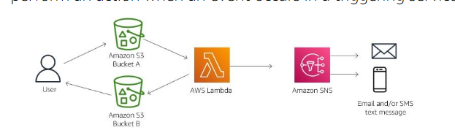

* In the example, a user uploads a photo into Amazon S3 – Bucket A.
* This action triggers the Lambda code to run and resize the photo and place the photo in Amazon S3 – Bucket B.
* From Bucket-B the user can download the resized photo. Lambda sends an email or text message to the appropriate users to alert them that the photo is ready to download.

**How can I use aws Lambda ?**

* **Web applications :**
  + By combining AWS Lambda with other AWS services, developers can build powerful web applications that automatically scale up and down.
  + These applications run in a highly available configuration across multiple datacenters -with zero administrative effort required for scalability, backups, or multi-data redundancy.
* **Data Processing :**
  + You can use AWS Lambda to execute code in response to triggers such as changes in data, shifts in system state, or actions by users.
  + Lambda can be directly triggered by AWS services such as Amazon S3, and cloudwatch, or it can be orchestrated to workflows by AWS Step functions. Thus, you can build a variety of real-time serverless data processing systems.
* **Real-time file processing :**
  + You can use Amazon S3 to trigger AWS Lambda to process data immediately after an upload.
  + You can also connect to an existing Amazon Elastic File System ( Amazon EFS ) file system directly, which enables massively parallel shared access for large-scale file processing.
  + For Ex: you can use Lambda to thumbnail images, transcode videos, index files, process logs, validate content, and aggregate and filter data in real-time.
* **Real-time Stream Processing :**
  + You can use AWS Lambda and Amazon Kinesis to process real-time streaming data for application activity tracking, transaction order processing and click stream analysis.
  + You can also use it for data cleansing, metrics generation, log filtering, indexing, social media analysis, and internet of things ( IOT ) device data telemetry and metering.

**What else should I keep in mind when using AWS Lambda ?**

* AWS Lambda has a 15 minutes limit on its runtime for each invocation.
* If your computing needs require more than 15 minutes for runtime, then you would need to use an EC2 instance instead of Lambda.

**How much does Aws lambda cost ?**

* With AWS lambda, you pay for what you use. You are charged based on the number of requests for your Lambda function and the duration. The time it takes for your code to run.
* The AWS Lambda always free usage tier includes 1 M free requests per month and 400000 GB-Seconds of compute time per month.
* No charge is incurred when your code is not running.

**Amazon Dynamo db :**

**What does Amazon dynamo db do ?**

* Amazon DynamoDB is a serverless non-relational database that can store and retrieve any amount of data and serve any level of request traffic. You can scale your database tables throughput capacity up or down without downtime. You can use the AWS Management console to monitor resource utilization and performance metrics.

**What problems does Amazon dynamo db solve ?**

* You can use DynamoDB to offload the administrative burdens of operating and scaling a distributed database.
* Therefore, you don’t need to worry about hardware provisioning, setup and configuration, replication, software patching or cluster scaling

**What are the benefits of Amazon dynamo db ?**

* DynamoDB supports some of the world’s largest scale applications by providing consistent, single-digit millisecond response times at any scale.
* DynamoDB is serverless with no servers to provision, patch or manage and no software to install, maintain or operate.
* DynamoDB supports ACID transactions so that you an build business-critical applications at scale. DynamoDB encrypts all data by default and provides fine-grained identity and access control on all your tables.

**How can I architect a cloud solution using Amazon dynamo db ?**

* You use Amazon DynamoDB to store an application’s stored data.

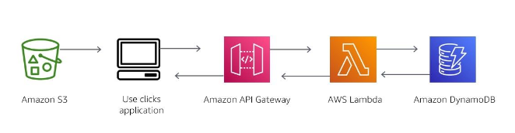

* In this example, a user accesses an application that is stored in Amazon S3. The user chooses an option to receive data. Amazon API Gateway will then trigger Lambda to retrieve data from DynamoDB and send it back to the user’s interface.

**How can I use amazon dynamo db ?**

**Retail :** Many companies in the retail space use common DynamoDB design pattern to deliver consistently low latency for mission-critical use cases. Being free from scaling concerns and operational burden is a key competitive advantage. It provides for high-velocity, extreme-scaled events such as Amazon Prime Day, these customers pay only the capacity that they need. They can keep precious technical resources focussed on innovations rather than operations.

**Gaming :** Companies in the gaming vertical use DynamoDB in all capabilities of game platforms, including game state, player data, session history, and leaderboards. The main benefit that these companies get from DynamoDB is its ability to scale reliably to milliions of concurrent users and requests while ensuring consistently low latency. This latency can be measured in single-digit milliseconds.

**Banking :** Banking and finance companies use DynamoDB to build more cloud-native applications to increase agility, reduce time to market, and minimize operational overhead. These companies also use DynamoDB to ensure the security, reliability, and continued high availability of their applications.

**Ad tech :** Companies in advertising technology ( ad-tech ) use DynamoDB as a key-value store for storing various kinds of marketing data. Examples of such data would include user profiles, user events, and visited links.

**What else should I keep in mind when using Amazon dynamo db ?**

DynamoDB is a non-relational database. If you need a relational database, you would use Amazon RDS.

**Relational Database :**

These store data in rows and columns. Rows contains all the information about one entry, and columns are the attributes that separate the data points. A relational database schema is fixed: columns must be locked before data entry. You can amend schemas if the database is altered entirely and taken offline. Data in relational database is queried by using a structured query language ( SQL ), which can have complex queries. Relational databases scale vertically by increasing hardware power. Relational databases are commonly used for traditional applications, enterprise resource planning ( ERP ), customer relationship management ( CRM ) and e-commerce.

**NON-Relational Database :** these store data by using one of the many storage models, including key-value pairs, documents and graphs. Non-Relational schemas are dynamic, and information can be added rapidly. Each row doesn’t have to contain data for each column. Data in non-relational database is queried by focussing on collections of documents. Non-relational databases scale horizontally by increasing servers. Key-value databases are commonly used for internet scale applications, realtime bidding, shopping carts and customer preferences.

**How much does Amazon dynamo db cost ?**

* DynamoDB charges for reading, writing, and storing data in your DynamoDB tables, along with any optional features you choose to enable. DynamoDB has two capacity modes ( on-demand and provisioned ) both of which come with specific billing options for processing reads and writes on your tables.